**Personal area**

Alfa Bank

Exported on Apr 16, 2021

**Table of Contents**

1 Terms and definitions 5

2 Address of the test personal area 6

3 Authentication and logging out of the personal area 7

3.1 The first login to the personal area 7

3.2 Standard login to the personal area 9

3.3 Log out of the personal area 10

4 Viewing charts 11

4.1 "Number of Transactions" chart 11

4.2 "Turnover" chart 12

4.3 "Conversion" chart 12

5 Receiving payments 13

5.1 Invoicing by email (without shopping cart) 13

5.2 Invoicing by email (with a shopping cart) 15

5.3 Creating a link to a pre-payment form 21

6 Catalog 24

7 Working with transactions 25

7.1 Search for transactions using a filter 25

7.2 Order completion 27

7.3 Cancellation and refund for the order 28

7.4 Viewing transaction details 29

7.5 Exporting a list of transactions 32

8 Settings 34

8.1 Basic settings 34

8.2 Fiscalization settings 35

8.3 Password change 37

8.4 Payment token 38

9 Working with certificates 39

9.1 Apple Pay 39

9.1.1 Certificate registration 39

9.1.2 Uploading a certificate signing request 42

9.1.3 Editing Merchant Apple ID 42

9.1.4 Setting a ban on the use of the certificate 43

9.2 Google Pay 44

9.2.1 Creating a key pair 45

9.2.2 Uploading a public key 46

9.2.3 Editing Google ID 46

9.2.4 Setting a ban on the use of a key pair 47

9.3 Samsung Pay 49

9.3.1 Creating a key pair 49

9.3.2 Uploading a certificate signing request 50

9.3.3 Setting a ban on the use of a key pair 51

10 Contacts and technical support 53

10.1 Contacts of the bank's services 53

10.2 Feedback 53

11 Processing system response codes 55

Table of Contents – 2

• Terms and definitions

• Address of the test personal area

• Authentication and logging out of the personal area

o The first login to the personal area

o Standard login to the personal area

o Log out of the personal area

• Viewing charts

o "Number of Transactions" chart

o "Turnover" chart

o "Conversion" chart

• Receiving payments

o Invoicing by email (without shopping cart)

o Invoicing by email (with a shopping cart)

o Creating a link to a pre-payment form

• Catalog

• Working with transactions

o Search for transactions using a filter

o Order completion

o Cancellation and refund for the order

o Viewing transaction details

o Exporting a list of transactions

• Settings

o Basic settings

o Fiscalization settings

o Password change

o Payment token

• Working with certificates

o Apple Pay

▪ Certificate registration

• Creating a key pair in the payment gateway

• Uploading a ready-made key pair and certificate to the payment gateway

▪ Uploading a certificate signing request

▪ Editing Merchant Apple ID

▪ Setting a ban on the use of the certificate

o Google Pay

▪ Creating a key pair

▪ Uploading a public key

▪ Editing Google ID

▪ Setting a ban on the use of a key pair

o Samsung Pay

▪ Creating a key pair

▪ Uploading a certificate signing request

▪ Setting a ban on the use of a key pair

• Contacts and technical support

o Contacts of the bank's services

o Feedback

• Processing system response codes

1. Terms and definitions

**Internet acquiring** is a modern way of selling services or goods via the public Internet using bank cards.

**Bank** is an acquiring bank that implements and operates a payment gateway.

**IPS** is an international payment system (for example, Visa International, MasterCard, etc.).

**Store** is a retailer and service outlet (RSO) that sells goods or provides services through a website.

**Order** is an elementary essence of the system, describes an order in an online store or its equivalent. Any order has an amount.

**One-phase payment** is an operation to pay for goods/services made via the Internet using bank cards, which does not require additional confirmation from the store.

**Two-phase payment** is an operation to pay for goods/services made via the Internet using bank cards, which requires additional confirmation from the store.

The two-phase mechanism of operation enables to separate the process of checking the solvency of a bank card (authorization) and withdrawing money (financial confirmation). At the first phase of a two-phase payment, the solvency of the bank card is checked and funds are blocked on the client's account. At the second phase - confirmation of funds debiting.

**Cancellation of the payment operation** (Reversal) is a removal of the block from the funds on the buyer's card. This function is available for a limited time, the exact terms must be specified in the bank.

**Refund** is a partial or full repayment of funds to the buyer's card in case of their refusal to receive the goods (services) or its return. The refund operation shall be performed after the funds are debited from the buyer's account.

**3-D Secure** is a Visa IPS technology that allows additional user authentication by means of the issuing bank.

**SecureCode** is a MasterCard IPS technology that allows additional user authentication by means of the issuing bank. Technologically, it is equivalent to 3-D Secure. In the text below, mentioning 3-D Secure also implies SecureCode.

**ACS** – Access Control Server, a 3D Secure infrastructure element that provides payer validation on the issuing bank's side.

**SSL payment** is an operation to pay for goods/services carried out without the use of 3DSecure technology.

**PAN** is a bank card number (from 12 to 19 digits).

**DPAN** – Device Primary Account Number, a value that is generated in the Apple Pay payment system and connects the mobile device with the bank card number. In this document, the bank card number (PAN) also means DPAN, if we are talking about a payment made using the Apple Pay system.

**BIN** – Bank Identification Number, the first 6 digits of the payment card number.

**Masked card number** is a card number in which only the first 6 digits (BIN) and the last 4 are left, and the remaining digits are replaced with two asterisks (example: 411111**1111).

1. Address of the test personal area

|  |  |
| --- | --- |
| **Test personal area** | <https://sandbox.egopay.ru/lk/login> |

1. Authentication and logging out of the personal area
   1. The first login to the personal area

When you first log in to your personal area, you need to change the user password assigned to you. This may also be necessary if the technical support operator has enabled this setting again. To log in with the replacement of the user's password, follow these steps.

1. In the browser, go to the address of your personal area.   
   The following page will be displayed.

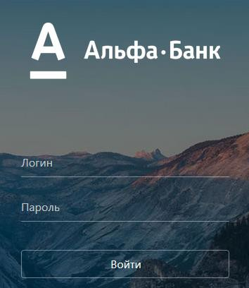

1. Follow these steps:
   1. in the **Login** field, enter the username of the user with the -operator suffix;
   2. in the **Password** field, enter the current value of the user's password.
2. Click the **Login** button.   
   The following page will be displayed.

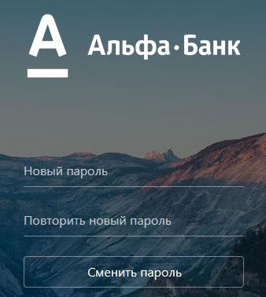

1. In the **New Password** and **Repeat New Password** fields, enter the new password and confirmation, respectively.
2. Click the **Change Password** button.

|  |
| --- |
| The password must contain characters from the following groups:   * letters (English and/or Russian) in uppercase (A-Z and/or А-Я); * letters (English and/or Russian) in lowercase (a-z and/or а-я); * digits (0-9); * special characters ( ! " № ; : ? * ( ) + = /\ < > , . [ ] { } ). The password must be at least 8 characters long. |

If the data entered is correct, the personal area page will be displayed.

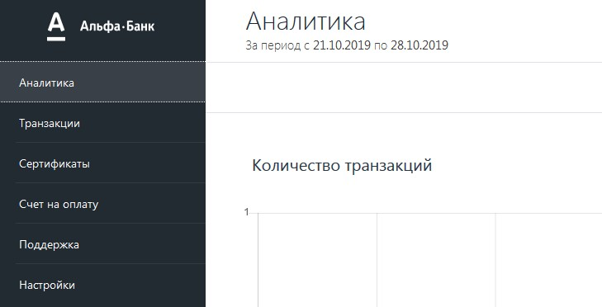

* 1. Standard login to the personal area

To log in to your personal area, follow these steps.

1. In the browser, go to the address of your personal area.   
   The following form will be displayed.



1. Follow these steps:
   1. In the **Login** field, enter the username with the **-opeartor** suffix.
   2. In the **Password** field, enter the password corresponding to the login.
2. Click the **Login** button.  
   If the data is entered correctly, the personal area page will be displayed.



* 1. Log out of the personal area

To log out of your personal area while in any section of your personal area, click your login in the upper right corner of the page and select **Log Out** from the list (see the image below).

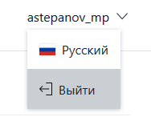

1. Viewing charts

The **Analytics** section allows you to analyze payment processing charts. The section displays three charts (see the table below).

|  |  |
| --- | --- |
| **Chart** | **Description** |
| Number of transactions | Total number of transactions. |
| Turnover | It displays the number of completed transactions and the number of transactions with refunds. |
| Conversion | The ratio of the number of successful transactions to the total number of transactions. |

In the upper right part of the page there is a menu that allows you to select the period for displaying charts (see the image below).



* **Day** — data for the elapsed day before the current time.
* **Week** — data for the past week up to and including the current day.
* **Month** — data for the past month up to and including the current day.
* **Year** — data for the past year up to and including the current day.
  1. "Number of Transactions" chart

The Number of Transactions chart shows the total number of transactions processed (see the image below).

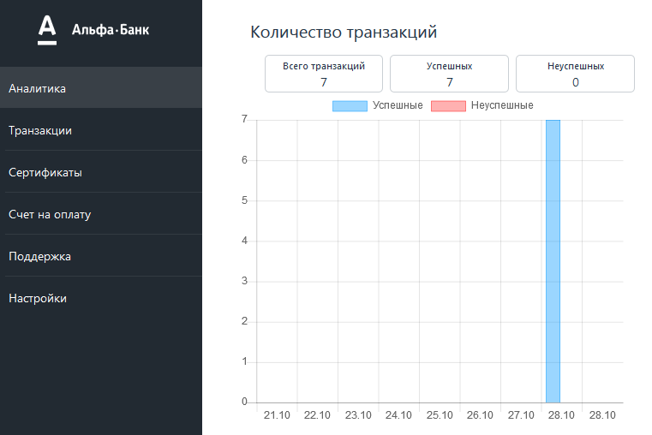

Above the chart there is information about the success of processed transactions:

* **Total transactions** — the total number of transactions processed.
* **Successful** — the number of successful transactions.
* **Unsuccessful** — the number of transactions that failed or were rejected.
  1. "Turnover" chart

The Turnover chart shows the amount of funds received and returned (see the image below).

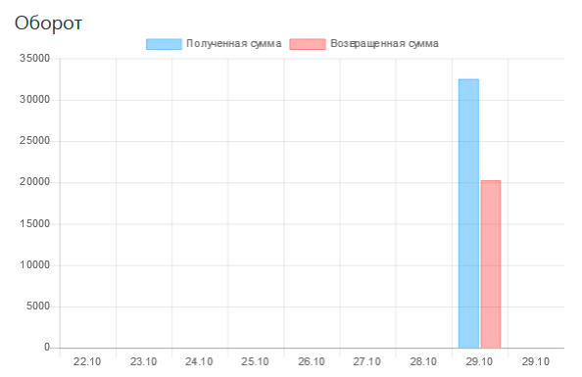

* 1. "Conversion" chart

The **Conversion** chart shows the ratio of successful orders to all orders made — as a percentage (see the image below).

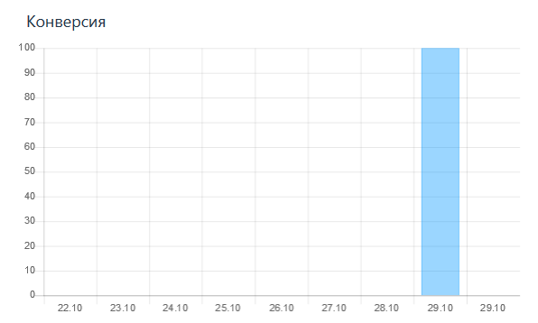

1. Receiving payments

The Invoice section allows you to issue an invoice to the buyer for the payment of goods or services. There are several ways to do this (see the table below).

|  |  |
| --- | --- |
| **Way** | **Description** |
| Sending a link to the payment form by email (without shopping cart) | Allows you to send a link to the payment page to the client's email address. At the same time, a shopping cart will not be created in the order |
| Sending a link to the payment form by email (with a shopping cart) | Allows you to send a link to the payment page to the client's email address. In this case, a shopping cart will be created in the order |
| Creating a link to a pre-payment form | It allows you to create a universal link to the payment page, which can be shared on social networks (Facebook, VK, Instagram, etc.), instant messenger apps (Telegram, Whatsapp, Viber, etc.). |

* 1. Invoicing by email (without shopping cart)

To issue an invoice to a client and send them a link to the payment page by email, follow these steps.

The **Invoice** section of the personal area allows you to issue an invoice

by e-mail.

By default, when you go to the section, the **Payment form** is displayed (see the image below).

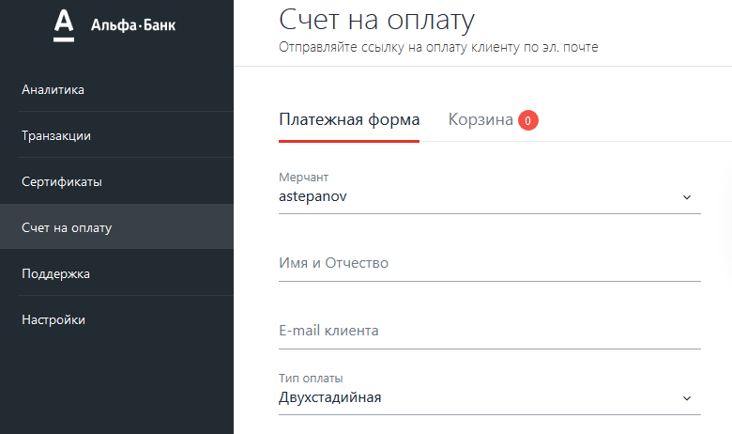

To issue an invoice, follow these steps.

1. Follow the table below to make the settings.

|  |  |
| --- | --- |
| **Setting** | **Description** |
| **Merchant** | Merchant's name in the payment gateway system. In most cases, this field is pre-filled in by default. |
| **First name and Patronymic** | The first name and patronymic of the client - this is how it will be displayed in the letter containing a link to the payment page. |
| **Payment type** | Choose one of the two options.   * **One-phase** - after making a payment, no additional actions are required on your part. * **Two-phase** - after the client has confirmed the payment, you must complete the payment in the personal area. Before you do this, the money will be held in the client's account (reserved) until you confirm the payment or until the confirmation waiting period expires.   If you confirm the payment, the money will be transferred to your account.  In case of expiration of the confirmation waiting period, the blocking of funds on the client's account will be removed. |
| **Currency** | Select the payment currency. |
| **Language** | Select the payment page display language. |
| **Order number** | The order number in the store's system.  This field may be unavailable if the payment gateway settings indicate that the number is generated by default. |
| **Lifetime of the issued invoice** | Specify the date and time before which the invoice can be paid. After this period, it will be impossible to pay the invoice. |
| **Payment description** | Description of the payment in free form. |
| **Payment amount** | Specify the payment amount.  If the order contains a pre-filled shopping cart, this field will be filled in by default. |

1. Click the **Send** button.

Upon successful order registration, the following message will be displayed.

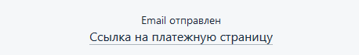

* 1. Invoicing by email (with a shopping cart)

To create an order with a payment shopping cart, follow these steps.

#### The beginning of the procedure

1. In the left navigation menu of your personal area, go to the **Invoice** section. The page will take the following form.

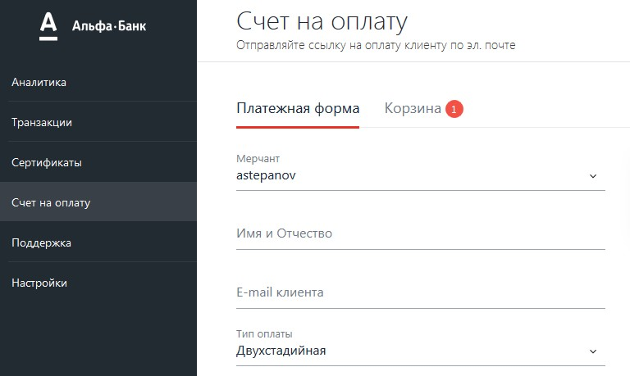

1. Go to the **Shopping Cart** tab. The page will take the following form.

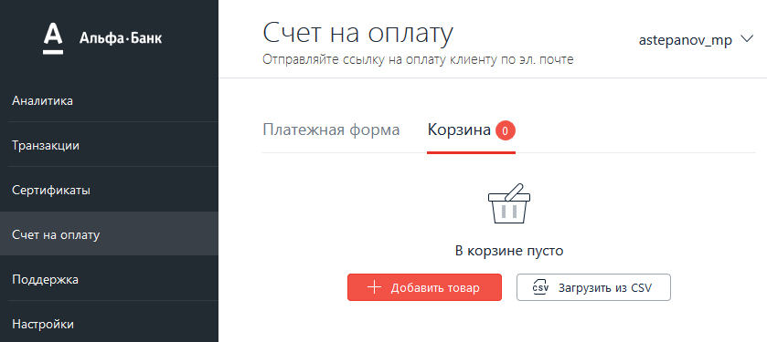

There are two ways to add a shopping cart to the order:

* add a product manually;
* upload a CSV file with a shopping cart.

And also, if the user has been assigned the appropriate permission, then in the **Shopping Cart** section there is an possibility to add products from the downloaded Catalog here (see the Catalog section).

Depending on the chosen method, follow the necessary steps and go on to complete the procedure.

#### Manual creation of a shopping cart

1. Click the **Add Product** button. The following form will be displayed.

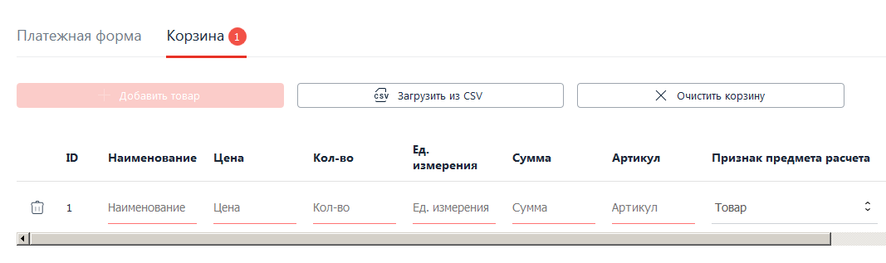

1. Fill in the fields following the table below.

| **Field** | **Description** |
| --- | --- |
| **ID** | The identifier of the product item, it is unique for the shopping cart. Filled in by default. |
| **Name** | The name of the product or service. |
| **Price** | The price per unit of the item. |
| **Qty** | The quantity of the product for this item. |
| **Unit of measurement** | Units of measurement, for example, l — liters, pcs — pieces. |
| **Amount** | The total amount for the entire line of the item. It is calculated by default when filling in the **Price** and **Quantity** fields. |
| **Article** | The article number of the product item. |
| **Attribute of the subject of payment** | Select the attribute of the subject of payment: Product;Excisable product;Work;Service;Gambling bet;Gambling winnings;Lottery ticket;Lottery winnings;Provision of IPR;Payment;  * **Agent fee**; * **Compound subject of payment**; * **Other subject of payment**. * **Property law**; * **Non-operating income**; * **Insurance premiums**; * **Trade fee**; * **Resort fee**; * **Deposit**. |
| **Attribute of the payment method** | Select the attribute of the payment method:   * **100% prepayment**; * **Partial prepayment**; * **Advance**; * **Payment in full**. |
| **Type of tax** | Select the tax rate:   * **Without VAT**; * **VAT at the rate of 0%**; * **VAT at the rate of 10%**; * **VAT at the estimated rate of 10/110**; * **VAT at the rate of 20%**; * **VAT at the estimated rate of 20/210**. |
| **Tax amount** | Enter the tax amount. |

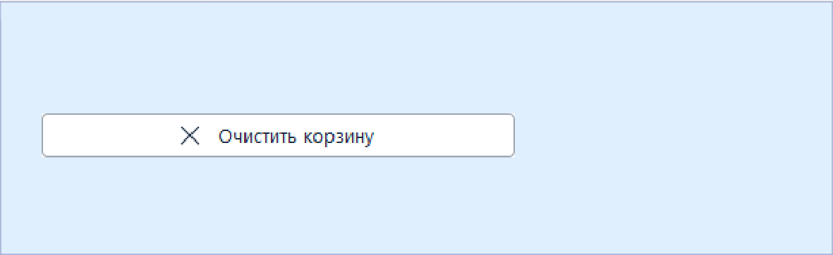

* To delete a product item, click the  icon in the line with the product item, and then click the **Confirm** button.
* To delete all the shopping cart, click the button

located above the list of product items, then click the **Confirm** button.

1. Proceed to the completion of the procedure.

#### Uploading a CSV file with a shopping cart

|  |
| --- |
| The CSV file for importing data about the shopping cart must be saved in UTF-8 encoding, commas must be used as a separator. Below is an example of the contents of the file. |

PositionId, Name, Amount, Quantity, Measure, Price, ItemCode, TaxType, TaxSum, PaymentMethod, PaymentSubject

1, Predoplata 100% + Tovar, 100, 10, piece, 10, qwerty1, 5, 50, 1, 1

2, Chastichnaya predoplata + Podakcizniy tovar, 100, 10, piece, 10,

qwerty2, 4, 50, 2, 2

3, Avans + Rabota, 100, 10, piece, 10, qwerty3, 3, 50, 3, 3

4, Polniy raschet + Usluga, 100, 10, piece, 10, qwerty4, 2, 50, 4, 4

5, Chastichniy raschet + stavka azartnoy igry, 100, 10, piece, 10,

qwerty5, 1, 50, 4, 4

6, Chastichniy raschet + stavka azartnoy igry, 100, 10, piece, 10,

qwerty6, 0, 50, 4, 4

|  |
| --- |
| The order of the fields in the CSV file does not matter. |

Below is a description of the fields.

| **Field** | **Description** |
| --- | --- |
| **PositionId** | Unique identifier of the product item inside the order shopping cart. |
| **Name** | The name or description of the product item in free form. |
| **Amount** | The amount of the payment in minimum currency units (kopecks, cents, etc.). No more than 12 characters. |
| **Quantity** | An element describing the total number of product items of one **PositionId** and their measure. Its attributes are described below. |
| **Measure** | Product item quantity measure, for example, l — liters, pcs. — pieces. |
| **Price** | The cost of one product item of one **PositionId** in minimum currency units (for example, in kopecks). Mandatory for sellers with fiscalization. |
| **itemCode** | The number (identifier) of the product item in the store's system. |
| PaymentSubject | Attribute of the subject of payment:   * **1** - product; * **2** - excisable product; * **3** - work; * **4** - service; * **5** - gambling bet; * **6** - gambling winnings; * **7** - lottery ticket; * **8** - lottery winnings; * **9** - payment; * **11** - agent fee; * **12** - compound subject of payment; * **13** - other subject of payment. * **14** - property law; * **15** - non-operating income; * **16** - insurance premiums; * **17** - trade fee; * **18** - resort fee; * **19** - deposit. |
| PaymentMethod | Attribute of the payment method:   * **1** - 100% prepayment; * **2** - Partial prepayment; * **3** - Advance; * **4** - Payment in full. |
| **TaxType** | VAT rate, the following values are available:   * **0 –** without VAT; * **1 –** VAT at the rate of 0%; * **2 –** receipt VAT at the rate of 10%; * **3 –** receipt VAT at the estimated rate of 10/110; * **4 –** receipt VAT at the rate of 20%; * **5 –** receipt VAT at the estimated rate of 20/120. |
| **TaxSum** | Tax amount. Specified in minimum currency units. |



* To delete a product item, click the  icon in the line with the product item, and then click the **Confirm** button.
* To delete all the shopping cart, click the button

located above the list of product items, then click the **Confirm** button.

To upload a file with the data of the shopping cart, follow these steps.

1. Click the **Upload from CSV** button.

The following pop-up window will be displayed.

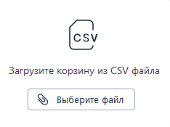

1. Click the **Select file** button and specify the path to the CSV file with data about the shopping cart.

After you specify the path to the file and confirm the selection, the following pop-up window will appear.

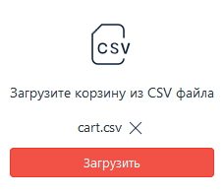

1. Click the **Upload** button.

If the file contained correct data, a successful download message will be displayed. Before completing the billing procedure, you can:

* edit the data of the shopping cart in the list of product items;
* add new product items, click the Add Product button (for more information, see Manual creation of a shopping cart).



* To delete a product item, click the  icon in the line with the product item, and then click the **Confirm** button.
* To delete all the shopping cart, click the button

located above the list of product items, then click the **Confirm** button.

Proceed to the completion of the procedure.

#### Adding a product from the catalog

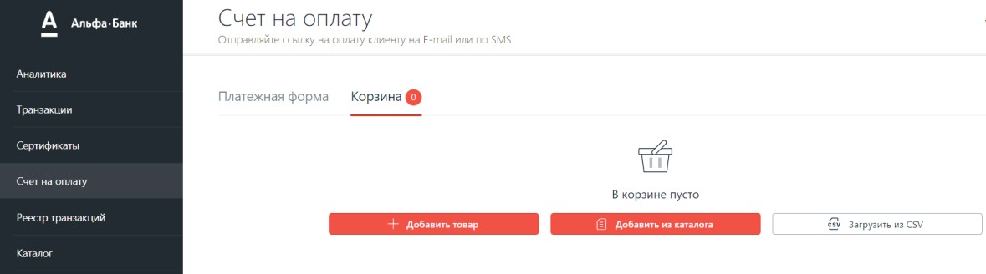

To add an item from the catalog, click the **Add from Catalog** button.

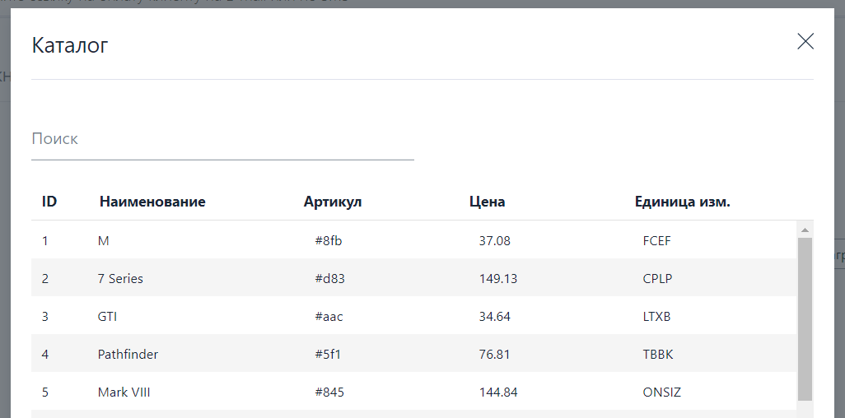

A window opens with a list of products that are contained in the Catalog. Click the desired product or several products in the list and click the **Add** button. Then the selected products will be automatically added to the Shopping Cart. Also here you can use the search for the necessary product from the Catalog using the **Search** field and the **Add** button.

Proceed to the completion of the procedure.

#### Completion of the procedure

To complete the procedure, go to the **Payment Form** tab (see the image below).



To issue an invoice, follow these steps.

1. Follow the table below to make the settings.

| **Setting** | **Description** |
| --- | --- |
| **Merchant** | Merchant's name in the payment gateway system. In most cases, this field is pre-filled in by default. |
| **First name and Patronymic** | The first name and patronymic of the client - this is how it will be displayed in the letter containing a link to the payment page. |
| **Payment type** | Choose one of the two options.   * **One-phase** - after making a payment, no additional actions are required on your part. * **Two-phase** - after the client has confirmed the payment, you must complete the payment in the personal area. Before you do this, the money will be held in the client's account (reserved) until you confirm the payment or until the confirmation waiting period expires.   If you confirm the payment, the money will be transferred to your account.  In case of expiration of the confirmation waiting period, the blocking of funds on the client's account will be removed. |
| **Currency** | Select the payment currency. |
| **Language** | Select the payment page display language. |
| **Order number** | The order number in the store's system.  This field may be unavailable if the payment gateway settings indicate that the number is generated by default. |
| **Lifetime of the issued invoice** | Specify the date and time before which the invoice can be paid. After this period, it will be impossible to pay the invoice. |
| **Payment description** | Description of the payment in free form. |
| **Payment amount** | Specify the payment amount.  If the order contains a pre-filled shopping cart, this field will be filled in by default. |

1. Click the **Send** button.

Upon successful order registration, the following message will be displayed.



* 1. Creating a link to a pre-payment form

To issue an invoice to a client and send them a link to the payment page by email, follow these steps.

The **Invoice** section of the personal area allows you to issue an invoice

by e-mail.

By default, when you go to the section, the **Payment form** is displayed (see the image below).



To issue an invoice, follow these steps.

1. Follow the table below to make the settings.

| **Setting** | **Description** |
| --- | --- |
| **Merchant** | Merchant's name in the payment gateway system. In most cases, this field is pre-filled in by default. |
| **First name and Patronymic** | The first name and patronymic of the client - this is how it will be displayed in the letter containing a link to the payment page. |
| **Payment type** | Choose one of the two options.   * **One-phase** - after making a payment, no additional actions are required on your part. * **Two-phase** - after the client has confirmed the payment, you must complete the payment in the personal area. Before you do this, the money will be held in the client's account (reserved) until you confirm the payment or until the confirmation waiting period expires.   If you confirm the payment, the money will be transferred to your account.  In case of expiration of the confirmation waiting period, the blocking of funds on the client's account will be removed. |
| **Currency** | Select the payment currency. |
| **Language** | Select the payment page display language. |
| **Order number** | The order number in the store's system.  This field may be unavailable if the payment gateway settings indicate that the number is generated by default. |
| **Lifetime of the issued invoice** | Specify the date and time before which the invoice can be paid. After this period, it will be impossible to pay the invoice. |
| **Payment description** | Description of the payment in free form. |
| **Payment amount** | Specify the payment amount.  If the order contains a pre-filled shopping cart, this field will be filled in by default. |

1. Click the **Send** button.

Upon successful order registration, the following message will be displayed.



1. Catalog

This page and its functionality are available to the user with the appropriate permission. If this condition is met, the page will look as follows:

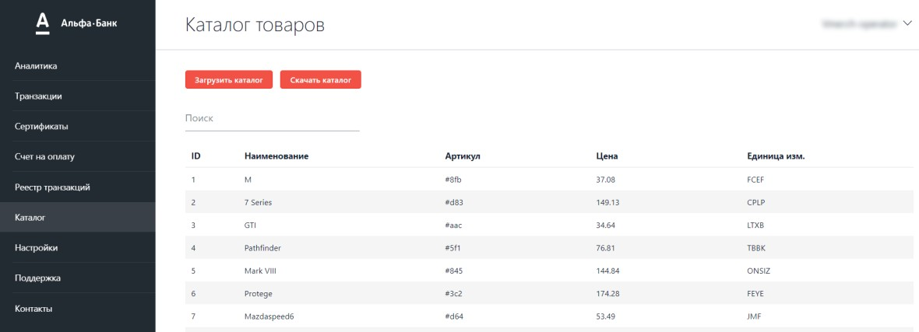

This page provides an opportunity to upload a ready-made product catalog - CSV file format. To upload the catalog, click **Upload Catalog**.

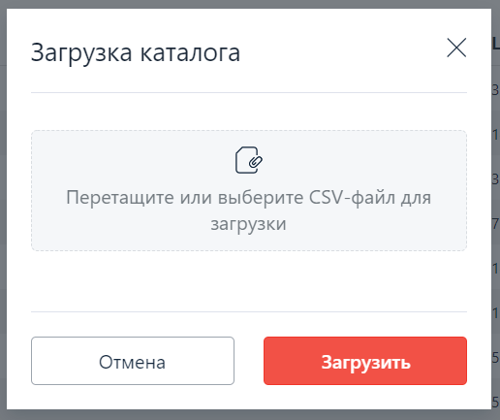

Drag and drop to the designated place or select the CSV file to upload and click **Upload.** A successfully uploaded catalog with product items will be displayed as a list on the page, as indicated above. This catalog can be downloaded by clicking the corresponding **Download Catalog** button.

It is also possible to search for a product in the catalog by any of the attributes of the product using the **Search** field. Enter the parameter to search for, and the product item itself will be selected from the list.

1. Working with transactions

The page of the **Transactions** section of the personal area looks as follows.

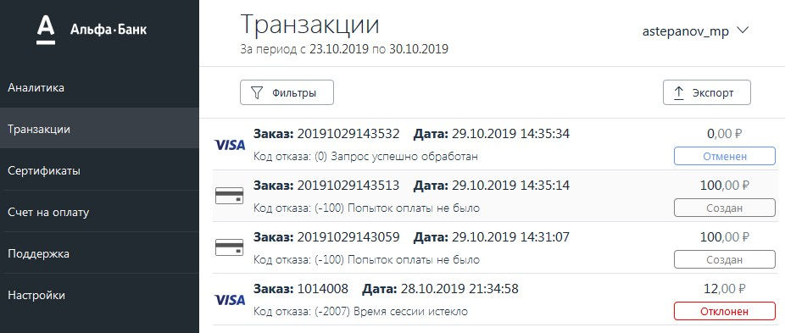

The section allows you to:

* search for transactions according to the specified criteria;
* export transaction lists;
* view transaction details;
* complete the order (for two-phase payments);
* cancel and refund the order.
  1. Search for transactions using a filter

To display transactions that meet certain criteria, follow these steps.

1. In the **Transactions** section of your personal area, click the  button.   
   The following form will be displayed on the right.

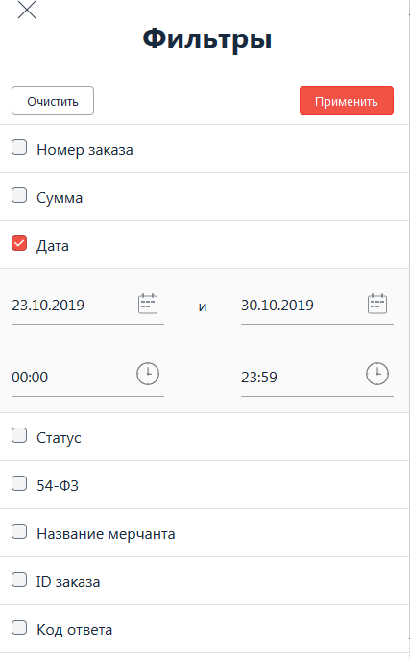

1. Fill in the required criteria using the table below.

| **Setting** | **Description** |
| --- | --- |
| **Order number** | Select the checkbox and enter the order number in the merchant's system in the displayed field. |
| **Amount** | Select the checkbox and in the displayed fields specify the minimum (field on the left) and maximum (field on the right) order amount. Use a comma as a separator for the minimum currency units. |
| **Date** | The checkbox is selected by default.  Specify the start date and time (on the left) and the end time (on the right) of the period for which you want to display orders. |
| **Status** | Select the checkbox and the order status in the drop-down list (you can select several options), the following options are possible.   * **Created** — the order is registered, but not yet paid-up; * **Confirmed** — the client has confirmed the payment, the funds are reserved on their account (for two-phase payments); * **Completed** — the order is paid-up; * **Refund** — a refund was made for the order; * **Cancelled** — a cancellation was made for the order; * **Rejected** — the order was rejected for some reason (for example, the payment waiting time expired). |
| **54-FZ** | Select the checkbox and select the fiscal status of the order in the drop-down list (you can select several options), the following options are available:   * **Sent** - the receipt has been sent; * **Delivered** - the receipt is delivered; * **Error** - an error occurred when sending or delivering the receipt. |
| **Merchant's name** | Select the checkbox to specify the merchant's name as a criterion. |
| **Order ID** | Select the checkbox and specify the order ID in the payment gateway system in the displayed field. |
| **Response code** | Select the checkbox and specify the processing system response code (see the section _bookmark95Processing system response codes). |
| **Card number** | Select the checkbox and specify the last 4 digits of the payer's card. |
| **Client's e-mail** | Select the checkbox and specify the client's email address. |

1. Click the **Apply** button.

The results will be displayed on the page (see the image below).

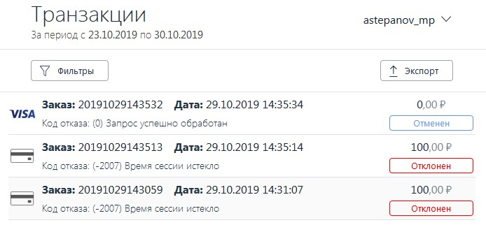

* You can:
* export the list of orders;
* view the details of an individual order;
* complete a confirmed order (for two-phase payments);
* make a cancellation or refund for the order.
  1. Order completion

To complete the transaction, follow these steps.

1. In the **Transactions** section of the personal area, search for the desired order using the filter.
2. In the list of search results, click the desired order.
3. In the lower left corner of the order summary section that appears, click the  button.

The Transaction Information page is displayed (see the image below).

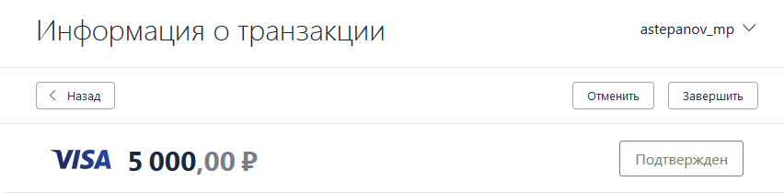

1. To complete the order, click the **Finish** button at the top right of the page.  
   The following form will be displayed.

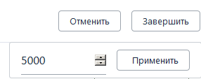

1. Depending on whether you want to complete the order for the full or partial amount, follow these steps:
   * completion for the full amount — click the **Apply** button;
   * completion for a partial amount — change the value in the editable field, then click the **Apply** button.

|  |
| --- |
| * The completion amount cannot exceed the initial order amount. * The order can be completed only once — after completion, it is impossible to re-complete for the remaining amount. |

* 1. Cancellation and refund for the order

You can cancel or refund the order. In the personal area interface, the Cancel button is used to perform both of these actions, however, changes in the order status depend on the following conditions (see the table below).

|  |
| --- |
| The end of the day is considered Moscow time. |

| **Initial order status** | **Cancellation/refund result** |
| --- | --- |
| **Completed** — one-phase payment. The day on which the payment was made  is not over yet. | * Full cancellation/refund — the order goes into the Canceled state. * Partial cancellation/refund — the order goes into the Refund state.   After carrying out a partial cancellation or refund, it is possible to carry out a second cancellation/refund, while the total amount of cancellations/refunds should not exceed the initial amount of the order. |
| **Completed** — one-phase payment, the day on which the payment was made is over. | * Full cancellation/refund — the order goes to the Refund state. * Partial cancellation/refund — the order goes to the Refund state.   After carrying out a partial cancellation or refund, it is possible to carry out a second cancellation/refund, while the total amount of cancellations/refunds should not exceed the initial amount of the order. |
| **Confirmed** - two-phase payment. | Full cancellation — the order goes to the **Canceled** state.  Partial cancellation of an order in the  **Confirmed status is** impossible. |
| **Completed** — two-phase payment. | * Full cancellation/refund — the order goes to the Refund state. * Partial cancellation/refund — the order goes to the Refund state. |

To cancel or refund, follow these steps.

1. In the **Transactions** section of your personal area, search for the desired order using the filter.
2. In the list of results, click the desired order.
3. In the transaction details section that appears, click the  button in the lower left corner of the section.

The Transaction Information page **is displayed**.

1. Click the  button in the upper corner of the page.
2. A cancellation/refund form will be displayed (see the image below).

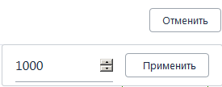

1. Follow these steps depending on whether you want to make a full or partial cancellation/refund:
   * full cancellation/refund — click the **Apply** button without changing the amount displayed.
   * partial cancellation/refund — change the amount of cancellation/refund in the editable field, then click the **Apply** button.

|  |
| --- |
| After carrying out a partial cancellation or refund, it is possible to carry out a second cancellation/refund, while the total amount of cancellations/refunds should not exceed the initial amount of the order. |

* 1. Viewing transaction details

To view the transaction details, follow these steps.

In the Transactions section of the personal area, search for the desired transactions using the order filter.

In the list of search results, click the desired order. Brief information about the order will be displayed (see the image below).

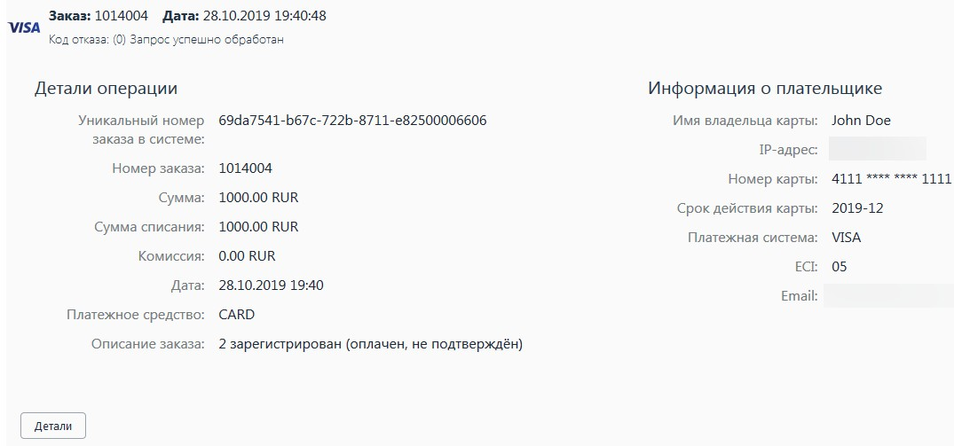

The following information is located at the top (see the table below).

|  |  |
| --- | --- |
| **Field** | **Description** |
| **Order** | The order number in the merchant's system. |
| **Date** | Order registration date. |
| **Failure code** | Processing system response code. |

The **Operation Details** section contains the following information (see the table below).

| **Field** | **Description** |
| --- | --- |
| **Unique order number in the system** | The order number in the payment gateway system. |
| **Order number** | The order number in the merchant's system. |
| **Amount** | Order amount. |
| **Debit amount** | How much funds were debited from the client's account. |
| **Fee** | Fee amount. |
| **Date** | Order registration date. |
| **Means of payment** | Payment method, the following options are available:   * **CARD** – payment with card data entry; * **CARD_BINDING** – payment by binding; * **CARD_PRESENT** – payment as cardPresent; * **ALFA_ALFACLICK**  – payment via Alfa-click; * **UPOP** – payment via China union pay; * **APPLE_PAY** – Apple Pay; * **APPLE_PAY_BINDING** – Apple Pay binding payment; * **GOOGLE_PAY_CARD** – Google Pay non-tokenized; * **GOOGLE_PAY_CARD_BINDING** – payment with a binding with a non-tokenized GooglePay card; |
|  | * **GOOGLE_PAY_TOKENIZED** – Google Pay tokenized; * **GOOGLE_PAY_TOKENIZED_BINDING** – payment with a binding with a tokenized GooglePay card; * **SAMSUNG_PAY** – Samsung Pay; * **SAMSUNG_PAY_BINDING** – payment with a Samsung Pay binding. |
| **Order description** | Description of the order in any form. |

The **Payer Information** section contains the following information (see the table below).

| **Field** | **Description** |
| --- | --- |
| **Cardholder's name** | Payer's name. |
| **IP address** | The IP address of the user who paid for the order. |
| **Card number** | The masked number of the card that was used for payment. |
| **Card expiration date** | The expiration date of the card in the YYYY-MM format. |
| **Payment system** | Payment system name. The following options are available. VISA;MASTERCARD;AMEX;  * **JCB**; * **CUP**; * **MIR**. |
| **ECI** | ECI is an electronic commercial identifier.   * ECI=1 or ECI=6 - merchant supports 3-D Secure technology, payment card does not support 3-D secure technology. * ECI=2 or ECI=5 - merchant and payment card support 3-D secure technology; * ECI=7 - merchant does not support 3-D Secure technology. |
| **Email** | Buyer's email address. |

To get more detailed information, click the  button in the lower left part of the order details section in the search results table.

The Transaction Information page is displayed.

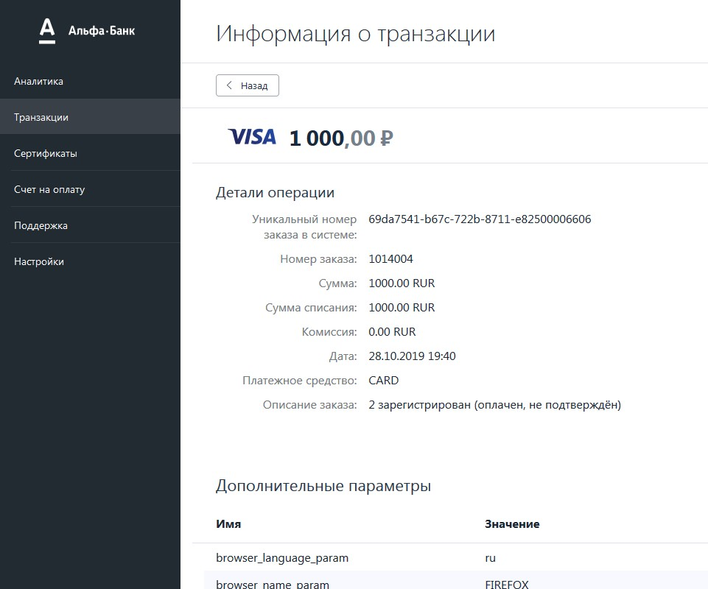

The **Operation details** and **Payer information** contained on the page of the section are described above. The page also contains the following sections.

The **Additional Parameters** section contains additional transaction parameters

— the table in this section has the following columns (see the table below).

|  |  |
| --- | --- |
| **Column** | **Description** |
| **Name** | The name of the additional parameter. |
| **Meaning** | The value of the additional parameter. |

The **History** section contains information about the order history — the table in this section has the following columns (see the table below).

|  |  |
| --- | --- |
| **Column** | **Description** |
| **Type of operation** | The type of operation performed with the order. |
| **Date** | Date and time of the operation. |
| **Description** | Description of the operation performed. |

* 1. Exporting a list of transactions

Orders from the personal area can be exported to an XLSX or CSV file. To export the list of orders, follow these steps.

1. In the **Transactions** section of your personal area, search for orders using the filter.
2. When the list of orders that meet the specified criteria is displayed, click the  button in the upper right part of the page.

The following pop-up window will be displayed.

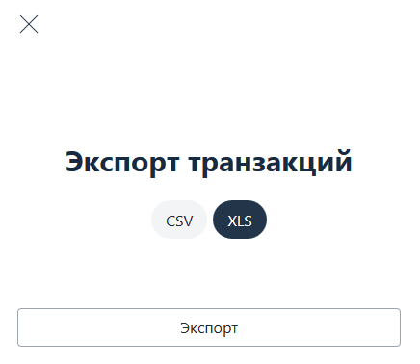

1. Click one of the following buttons:
   * **CSV** — for exporting the list of orders in CSV format;
   * **XLS** — for exporting the list of orders in XLSX format.
2. Click the **Export** button.
3. Depending on your browser settings, the list of orders will be saved to the default folder or the save paths window will be displayed — in the latter case, specify the save path and confirm the choice.

The list of orders is saved.

1. Settings
   1. Basic settings

The **Basic Settings** section allows the seller's operator to independently configure certain account settings and permissions.

To go to the **Basic Settings** section, select the

**Settings** section on the side menu, and then select **Basic Settings** in the **Seller** block. A page with account settings will be displayed (see the picture below).

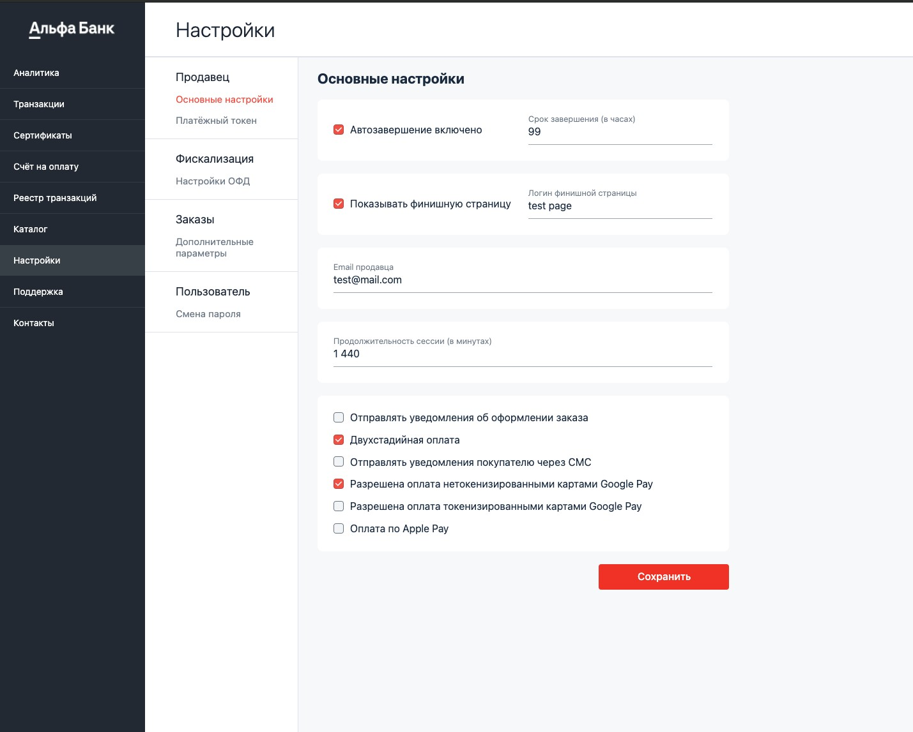

The settings are described in the table below.

| **Field** | **Description** |
| --- | --- |
| **Auto completion enabled** | If enabled, it allows you to specify in the **Completion Date field (in hours)** the number of hours after which two-phase payments will be automatically completed. |
| **Completion date (in hours)** | The number of hours after which two-phase payments will be automatically completed.  It shall be filled in if **Auto-completion is enabled**. |
| **Show the final page** | If enabled, it allows you to set an arbitrary payment completion page in the **Login of the final page** field. |
| **Login of the final page** | The name of the directory where the payment completion page files are located. It shall be filled if **Show the final page** is checked. |
| **Seller's email** | The seller's email address to which notifications will be sent.  You can specify multiple email addresses in the field (separated by commas). |
| **Session duration (in minutes)** | The period for entering card data from the moment of registration of the payment. If the payment is not made within the specified period, the order will switch to the DECLINED status. |
| **Send notifications about placing an order** | If enabled, the seller will receive an email notification about ordering. |
| **Two-phase payment** | Permission to use a two-phase payment pattern. |
| **Send notifications to the buyer via SMS** | If enabled, the buyer will receive SMS notifications. |
| **Payment with tokenized Google Pay cards is allowed** | Permission to use payment with tokenized Google Pay cards. |
| **Payment with *non*-tokenized Google Pay cards is allowed** | Permission to use payment  with *non*-tokenized Google Pay cards. |
| **Payment via Apple Pay** | Permission to use payment via Apple Pay. |

* 1. Fiscalization settings

To set/edit the fiscalization settings, follow these steps.

1. In your personal area, go to the **Settings** section.

The fiscalization **Settings** tab will be displayed automatically (see the image below).

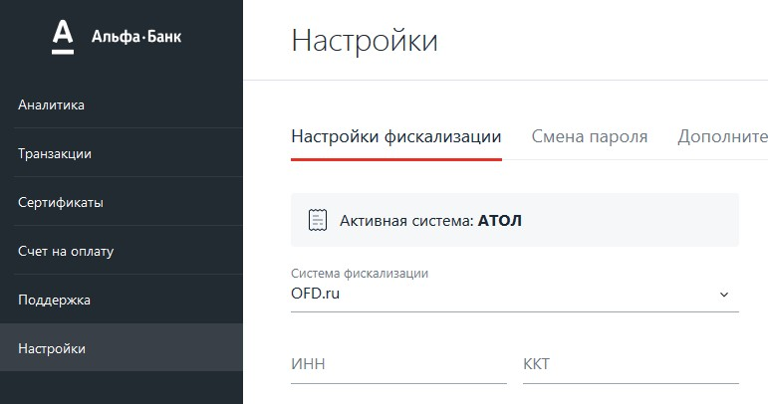

1. To set/edit the fiscalization settings, follow the steps provided in the table below.

| **Field** | **Description** |
| --- | --- |
| **Active system** | Non-editable field. This field displays the active fiscal data operator. |
| **Fiscalization system** | Select an available fiscal data operator from the drop-down list: Orange Data;ATOL;Alfa-Cash Register;OFD.ru.EKAM |
| **Version** | The setting is displayed only if the ATOL FDO is selected. |
| Allows you to select the version of the fiscal document format (FDF):  • **1.0**;  • **1.05**. |
| Always choose version 1.05. |
| Irrelevant for **OFD.ru** . |
| **TIN** | Enter the taxpayer individual number. |
| **CRE** | Enter the number of the cash register equipment. |
| **Login** | Enter the login to access the FDO. |
| **Password** | Enter the password corresponding to the login to access the FDO. |
| **Tax rate** | Select the tax rate: Without VAT;VAT at the rate of 0%;VAT at the rate of 10%;VAT at the estimated rate of 10/110;VAT at the rate of 20%;VAT at the estimated rate of 20/210. |
| **Taxation system** | Choose a taxation system: General taxation system ;Simplified taxation system (income);Simplified taxation system (income minus expenses);Single imputed tax expense;Unified agricultural tax;Patent taxation system. |
| **Attribute of the subject of payment** | Select the attribute of the subject of payment: Product;Excisable product;Work;Service;Gambling bet;Gambling winnings;Lottery ticket;Lottery winnings;Provision of IPR;Payment;Agent fee;Compound subject of payment;Other subject of payment.Property law;Non-operating income;Insurance premiums;Trade fee;Resort fee;Deposit. |
| **Attribute of the payment method** | Select the attribute of the payment method: 100% prepayment;Partial prepayment;Advance;Payment in full. |
| **Product name** | Enter the product name. |
| **URL** | Enter the URL of your online store. |
| **Default email** | Enter your email address. |
| **The phase of generating a receipt for a two-phase payment** | When using two-phase payment, select at which phase the receipt will be created:   * **At the holding stage** — the user has confirmed the payment, but the order is still in the **Confirmed** phase, the funds are reserved on the user's account: * **At the completion stage** — the order is in the   Completed **phase.** |
| **FDO enabled** | If the check box is selected, the edited fiscal data operator is active. |

1. Click the **Send** button.

The settings of the fiscal data operator are saved.

* 1. Password change

To change the password to access your personal area, follow these steps.

1. In the **Settings** section of your personal area, go to the **Change Password** tab.

The tab will look as follows.

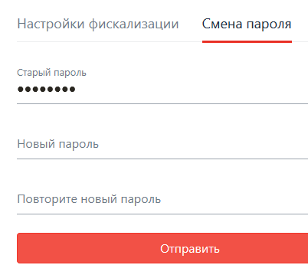

1. In the **Old Password** field (if it is not pre-filled in), enter the value of the current password.
2. In the **New Password** and **Confirm New Password** fields, enter the new password and confirmation, respectively.

The password must contain characters from the following groups:

* letters (English and/or Russian) in uppercase (A-Z and/or А-Я);
* letters (English and/or Russian) in lowercase (a-z and/or а-я);
* digits (0-9);
* special characters ( ! " № ; : ? * ( ) + = /\ < > , . [ ] { } ).  
  The password must be at least 8 characters long.

1. Click the **Send** button.

The password to access the personal area has been changed.

* 1. Payment token

Payment token is a value that allows the merchant to authenticate in the payment gateway when interacting via the API. The payment token is used instead of the api user's username and password in REST requests. To display the payment token, follow these steps.

In the personal area **Settings** section, go to the **Payment Token** tab.

A page containing the value of the payment token will be displayed (see the image below).

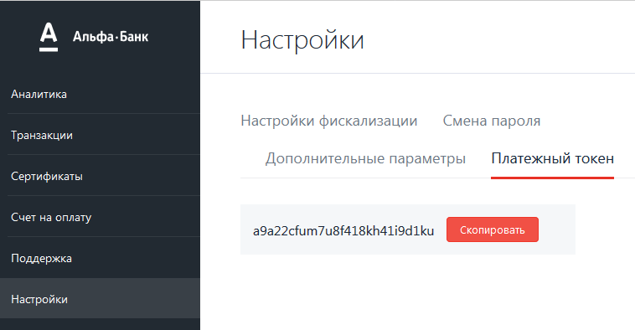

You can copy the payment token to the clipboard by clicking the **Copy** button.

1. Working with certificates

The **Certificates** section allows you to create certificates for use in payments of the following systems:

* Apple Pay;
* Google Pay;
* Samsung Pay.
  1. Apple Pay

To work with Apple Pay certificates, select the Certificates section in the left navigation menu of your personal area. The **Apple Pay** tab will be displayed automatically (see the image below).

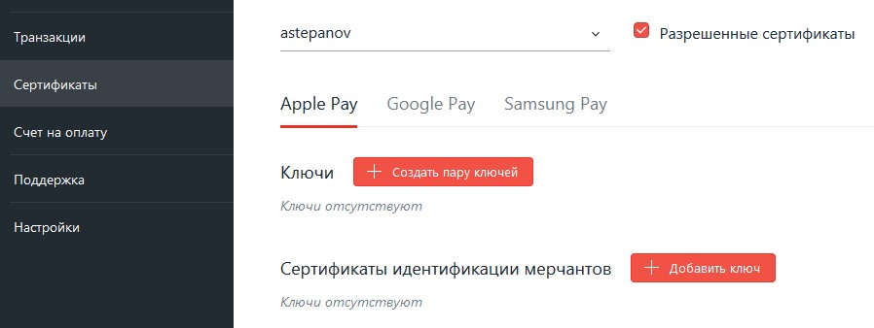

* + 1. Certificate registration

To accept payments via Apple Pay, you must have a key pair and public key certificate corresponding to this key pair. The certificate must be registered in the Apple Pay system and in the payment gateway system.

Follow the necessary steps, depending on whether you have a key pair and the corresponding public key certificate registered with Apple Pay.

|  |  |
| --- | --- |
| **You have no key pair and public key certificate** | Follow these steps.   1. Create a key pair 2. Download the certificate signing request from your personal area. 3. Sign the certificate in Apple Pay.   Subsequently, the following actions will be available to you.   * Editing the Apple Merchant ID, * Setting a ban on the use of the certificate. |
| **You have a key pair and a public key certificate registered with Apple Pay** | Upload the file containing the key pair in the personal area of the payment gateway.  Subsequently, the following actions will be available to you.   * Editing the Apple Merchant ID, * Setting a ban on the use of the certificate. |

* + - 1. Creating a key pair in the payment gateway

To create a key pair, follow these steps.

1. Click the **Create Key Pair** button. The following window will be displayed.

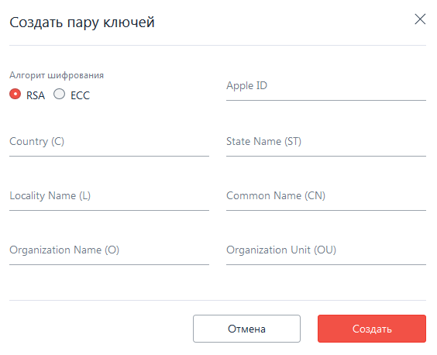

1. Follow the table below to make the settings.

| **Setting** | | **Description** | |
| --- | --- | --- | --- |
| **Encryption algorithm** | | The value of the Merchant Apple ID. | |
| **Country (C)** | | Enter the two-letter ISO code of the country where your organization is located. | |
| **Locality Name (L)** | | Enter the name of the locality where your organization is located. | |
| **Organization Name (O)** | | Enter the name of your organization. | |
| **Apple ID** | | The value of the Merchant Apple ID. | |
| **State Name** | | Enter the name of the region where your organization is located. | |
| **Common Name** | | Enter the full domain name of your website, for example, **test.com** . | |
| **Organization Unit** | | Enter the name of your organization's department. | |

1. Click the **Create** button.

If the key is successfully created, the corresponding line will be displayed in the personal area interface (see the image below).

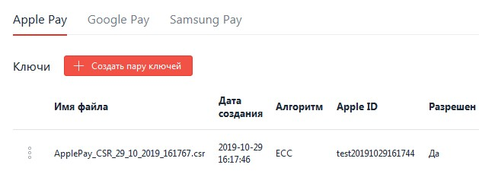

Proceed to uploading the certificate signing request.

* + - 1. Uploading a ready-made key pair and certificate to the payment gateway To add an existing key pair, follow these steps.

1. In the Merchant Identification Certificates section**,** click the **Add Key button.**

The following window will be displayed.

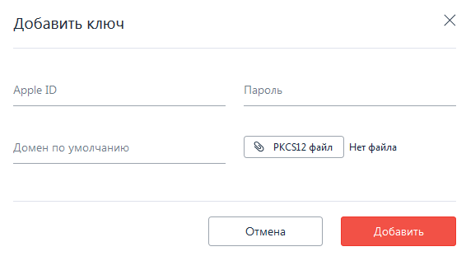

1. Follow the required steps provided in the table below.

| **Setting** | **Description** |
| --- | --- |
| **PKCS12 file** | Click the  button and specify the path to the file containing the key pair. |
| **Password** | Enter the password protecting the contents of PKCS12 file. |
| **Default domain** | Specify the domain of your store. |
| **Apple ID** | Specify the Merchant Apple ID. |

1. Click **Add**.

If the procedure is successful, the imported certificate will be displayed in the list (see the image below).

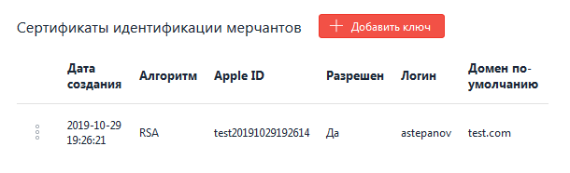

Next, the following actions are available with the certificate.

* Edit Merchant Apple ID.
* Ban on the use of the certificate.
  + 1. Uploading a certificate signing request

To upload a certificate signing request, follow these steps.

1. Click the  icon in the line with the required certificate and select **Upload CSR**

(see the image below).

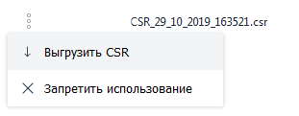

The window for saving the certificate signing request file will be displayed.

1. Specify the path to save the file or save it to the default folder.

Now you can upload a certificate signing request in your Apple Pay personal area. The following actions are also available to you.

* Editing the Apple Merchant ID.
* Setting a ban on the use of the certificate.
  + 1. Editing Merchant Apple ID

To edit Apple Pay, follow these steps.

1. Click the  icon next to the required certificate and select Edit (see the image below).

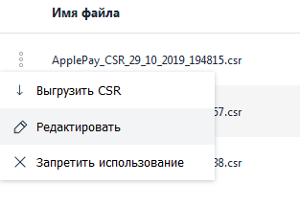

The following window will be displayed.

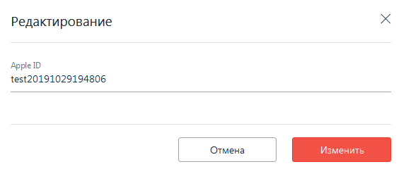

1. Edit the value of the **Apple ID** field, then click the **Edit** button.
   * 1. Setting a ban on the use of the certificate

To prohibit further use of the certificate/key, follow these steps.

|  |
| --- |
| The result of this procedure is irreversible. |

1. Click the  icon in the line of the required certificate and select **Prohibit use** (see the image below).

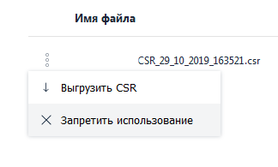

The following window will be displayed.

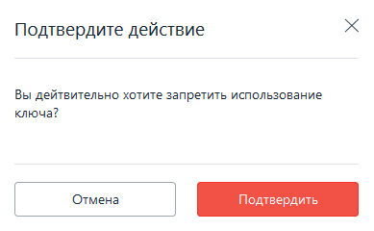

1. Click the **Confirm** button.

The display of a certificate whose use is prohibited depends on the **Allowed Certificates** checkbox located at the top of the **Certificates** section (see the image and table below).

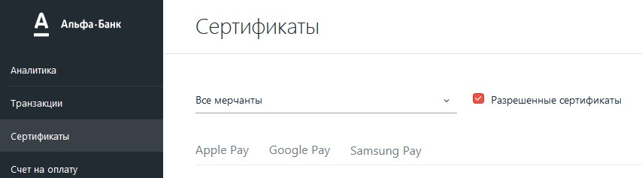

|  |  |
| --- | --- |
| **The checkbox is selected** | Certificates whose use is prohibited are not displayed in the list of certificates. |
| **The checkbox is unchecked** | Certificates whose use is prohibited are displayed in the list, but in the Allowed column opposite this certificate there is No (see the image below). |

* 1. Google Pay

This section allows you to manipulate Google Pay key pairs and certificates. To get to the section, follow these steps.

1. In the left navigation panel of your personal area, select the **Certificates** section.
2. On the page that appears, select the **Google Pay** tab.

If the key pairs have not been created yet, the tab will look as follows.

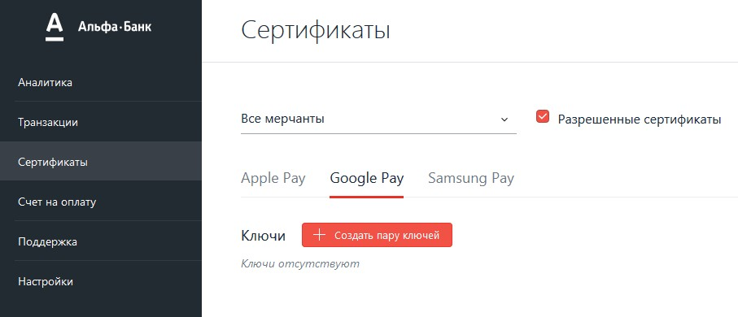

To interact with the Google Pay system, you need to perform the following steps.

1. Register in the Google Pay system.
2. Create a key pair in the personal area of the payment gateway.
3. Upload the public key of the created key pair from your personal area.
4. Register the public key in the Google Pay system.

Also, the following operations are available in the personal area.

* Editing Google ID.
* Setting a ban on the use of a key pair.
  + 1. Creating a key pair

To create a key pair, follow these steps.

1. In the **Certificates** section of your personal area, select the **Google Pay** tab.
2. In the **Keys** section, click the **Create Key Pair** button. The following window will be displayed.

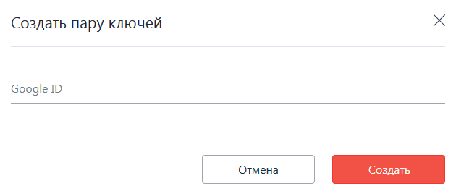

1. In the **Google ID** field, enter your Google ID received in the Google Pay system, and then click the **Create** button.

In case of successful creation, the data about the new key pair will be displayed in the table below (see the image below).

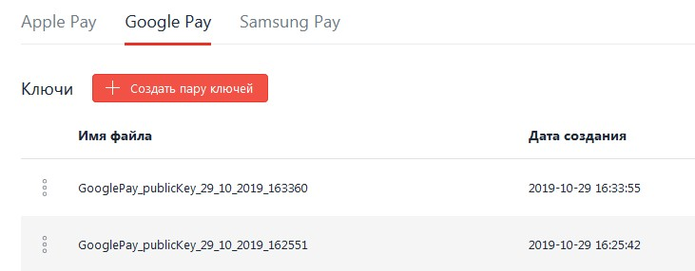

Now you can upload the public key and register it in Google Pay.

* + 1. Uploading a public key

To upload a public key to register it in Google Pay, follow these steps.

1. In the **Certificates** section of your personal area, select the **Google Pay** tab.
2. Click the  icon next to the required certificate and select **Upload Key**

(see the image below).

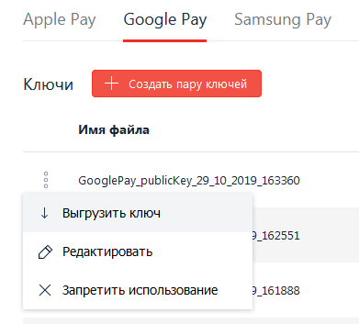

1. In the window that appears, specify the path to save the public key file or select the default save path.

The public key is saved — now you can register it in the Google Pay system.

Also, the following actions are available to you.

* Editing Google ID.
* Setting a ban on the use of a key pair.
  + 1. Editing Google ID

To edit Google ID in your personal area, follow these steps.

1. In the list of key pairs, click the  icon and select **Edit** (see the image below).

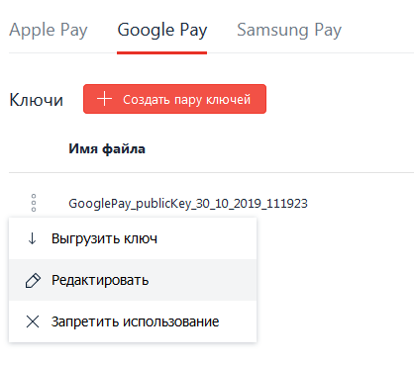

The following window will be displayed.

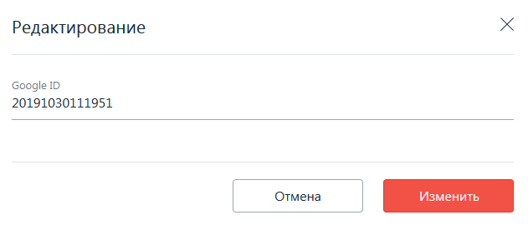

1. Edit the value of the **Google ID** field, then click **Edit**. Google ID has been edited.
   * 1. Setting a ban on the use of a key pair

To prohibit further use of the certificate/key, follow these steps.

|  |
| --- |
| The result of this procedure is irreversible. |

1. Click the  icon in the line of the required certificate and select **Prohibit use** (see the image below).



The following window will be displayed.



1. Click the **Confirm** button.

The display of a certificate whose use is prohibited depends on the **Allowed Certificates** checkbox located at the top of the **Certificates** section (see the image and table below).



|  |  |
| --- | --- |
| **The checkbox is selected** | Certificates whose use is prohibited are not displayed in the list of certificates. |
| **The checkbox is unchecked** | Certificates whose use is prohibited are displayed in the list, but in the Allowed column opposite this certificate there is No (see the image below). |

* 1. Samsung Pay

The Samsung Pay section allows you to perform operations with Samsung Pay certificates. To get to the section, follow these steps.

1. In the left navigation menu of your personal area, select the **Certificates** section.
2. On the page that appears, select the **Samsung Pay** tab.  
   If Samsung Pay certificates have not been created before, the tab will look as follows.

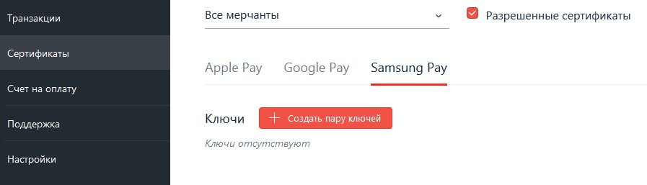

To accept Samsung Pay payments, follow these steps.

1. Create a key pair in your personal area.
2. Upload the certificate signing request.
3. Using the certificate signing request, register the certificate in the Samsung Pay system.

Also, in the Samsung Pay section, you can set a ban on the use of a previously created key pair and its corresponding public key certificate.

* + 1. Creating a key pair

To create a key pair, follow these steps.

1. In the **Certificates** section of your personal area, select the **Samsung Pay** tab.
2. In the **Keys** section, click the **Create Key Pair** button.

The following window will be displayed.

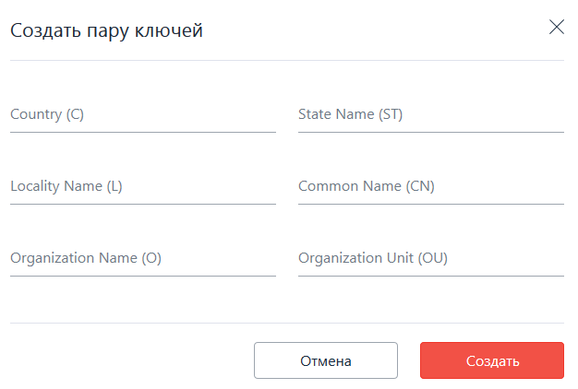

1. Fill in the fields following the table below.

|  |  |
| --- | --- |
| **Field** | **Description** |
| **Country (C)** | Enter the two-letter ISO code of the country where your organization is located. |
| **State Name (ST)** | Enter the name of the region where your organization is located. |
| **Locality Name (L)** | Enter the name of the locality where your organization is located. |
| **Common Name (CN)** | Enter the full domain name of your website, for example, **test.com** . |
| **Organization Name (O)** | Enter the name of your organization. |
| **Organization Unit (OU)** | Enter the name of your organization's department. |

1. Click the **Create** button.

The created key pair will be displayed in the table below (see the image below).

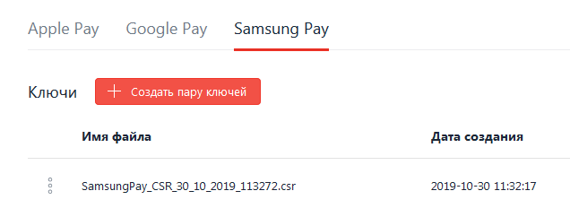

Proceed to uploading the certificate signing request.

* + 1. Uploading a certificate signing request

To upload a certificate signing request, follow these steps.

1. Click the  icon in the line with the required certificate and select **Upload CSR**

(see the image below).



The window for saving the certificate signing request file will be displayed.

1. Specify the path to save the file or save it to the default folder.

Now you can register your certificate by uploading a certificate signing request to Samsung Pay.

You can also set a ban on using the Samsung Pay certificate.

* + 1. Setting a ban on the use of a key pair

To prohibit further use of the certificate/key, follow these steps.

|  |
| --- |
| The result of this procedure is irreversible. |

1. Click the  icon in the line of the required certificate and select **Prohibit use** (see the image below).



The following window will be displayed.



1. Click the **Confirm** button.

The display of a certificate whose use is prohibited depends on the **Allowed Certificates** checkbox located at the top of the **Certificates** section (see the image and table below).



|  |  |
| --- | --- |
| **The checkbox is selected** | Certificates whose use is prohibited are not displayed in the list of certificates. |
| **The checkbox is unchecked** | Certificates whose use is prohibited are displayed in the list, but in the Allowed column opposite this certificate there is No (see the image below). |

1. Contacts and technical support

The **Support** section of the personal area contains the contact details of the bank's representatives, and also allows you to send a message to the bank's representatives.

For more information, see:

* viewing contacts of the bank's representatives;
* sending a message to the bank's representatives.
  1. Contacts of the bank's services

To display the contacts of the bank's services, follow these steps.

1. Log in to your personal area.
2. In the navigation menu on the right, click **Support**.

The **Contacts** section will be displayed by default (see the image below).

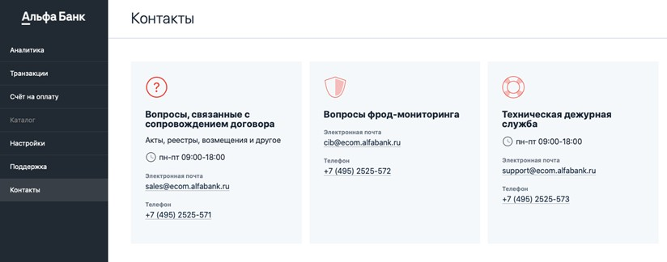

This section provides contact details for contacting the following services.

* + Services on issues related to the maintenance of the contract.
  + Fraud Monitoring Service.
  + Technical hotline service.
  1. Feedback

To send a message to technical support, follow these steps.

1. Log in to your personal area.
2. In the navigation menu on the right, select **Support**.
3. On the page that appears, go to the **Feedback** tab.

The page will take the following form.

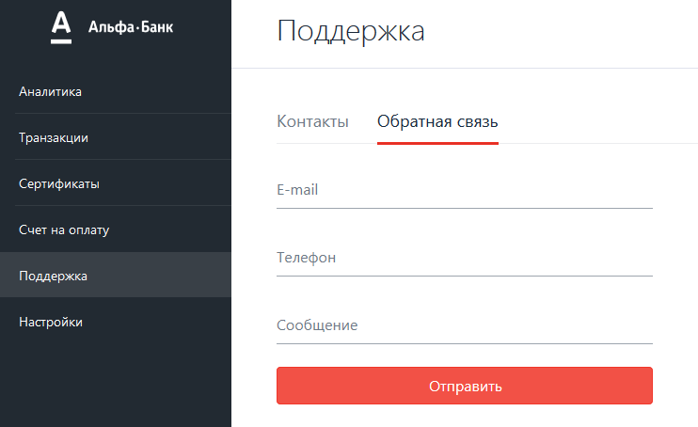

1. Fill in the required fields, following the table below.

|  |  |
| --- | --- |
| **Field** | **Description** |
| **E-mail** | Your email address where the response to your request will be received. |
| Both **E-mail** and **Phone** fields cannot be empty. |
| **Phone** | Your phone number where technical support staff will call you back. |
| Both **E-mail** and **Phone** fields cannot be empty. |
| Acceptable phone number formats:   * +79998887766 ; * 79998887766; * 89998887766. |
| **Message** | The text of the message. |

1. Click the **Send** button.

A message about the successful submission will be displayed.

1. Processing system response codes

The response code is a digital designation of the result that the user's operation in the system led to. The following codes are defined in the system.

| **Action code** | **error_id** | **error_message** | **Description** | **Messages recommended for the Client** |
| --- | --- | --- | --- | --- |
| -20010 | -20010 | Blocked by limit | The transaction was rejected due to the fact that the payment amount exceeded the limits set by the Issuing Bank | Payment error. Try again later. If this error occurs again, contact your Bank to clarify the reasons.  The bank's phone number must be indicated on the back of the card. |
| -9000 | -9000 | Started | Transaction start status | *When this actionCode occurs, the message is not displayed to the Client.* |
| -3003 | -3003 | Unknown | Unknown | Payment error. Try again later. |
| -2102 | -2102 | Blocked by passenger name | Blocked by passenger name | Payment error. Contact the store's representative for the reasons. |
| -2101 | -2101 | Blocked by e-mail | Blocked by e-mail | Payment error. Contact the store's representative for the reasons. |
| -2025 | -2025 | Rejected. RReq status is not "Y" | Rejected. RReq status is not "Y" | Payment error. Contact the store's representative for the reasons. |
| -2024 | -2024 | Rejected. Partial 3D Secure (v.2) is prohibited | Rejected. Partial 3D Secure (v.2) is prohibited | Payment error. Contact the store's representative for the reasons. |
| -2023 | -2023 | "U" in ARes | "U" in ARes | Payment error. Contact the store's representative for the reasons. |
| -2020 | -2020 | Invalid ECI received | Invalid ECI received. The code is set if the ECI that came to PaRes does not match the acceptable  value for this IPS. The rule only works for MasterCard (01.02) and  Visa (05.06), where the values in parentheses are valid for IPS. | Payment error. Try again later. |
| -2019 | -2019 | Rejected as per iReq in PARes | PARes from the issuer contains iReq, as a result of which the payment was rejected | Payment error. Try again later. If this error occurs again, contact your Bank to clarify the reasons.  The bank's phone number must be indicated on the back of the card. |
| -2018 | -2018 | Rejected. DS connection timeout | The Visa or MasterCard directory server is either unavailable, or a communication error has arrived in response to the card enrolment request (VeReq). This is an error in the interaction of the payment gateway and the IPS servers due to technical problems on the side of the latter. | Payment error. Try again later. |
| -2017 | -2017 | Rejected. PARes status is not "Y" | Rejected. PARes status is not "Y" | Payment error. Contact the store's representative for the reasons. |
| -2016 | -2016 | U in VERes | The issuing bank could not determine whether the card is 3dsecure. | Payment error. Try again later. If this error occurs again, contact your Bank to clarify the reasons.  The bank's phone number must be indicated on the back of the card. |
| -2015 | -2015 | Rejected as per iReq in VERes | VERes from DS contains iReq, as a result of which the payment was rejected. | Payment error. Try again later. If this error occurs again, contact your Bank to clarify the reasons.  The bank's phone number must be indicated on the back of the card. |
| -2013 | -2013 | Payment attempts exhausted | Payment attempts exhausted. | Payment error. Try again later. |
| -2012 | -2012 | The operation is not supported | This operation is not supported. | Payment error. Try again later. |
| -2011 | -2011 | U in PARes | The issuing bank was unable to authorize the card's 3dsecure | Payment error. Try again later. If this error occurs again, contact your Bank to clarify the reasons.  The bank's phone number must be indicated on the back of the card. |
| -2010 | -2010 | XID mismatch | XID mismatch. | Payment error. Try again later. If this error occurs again, contact your Bank to clarify the reasons.  The bank's phone number must be indicated on the back of the card. |
| -2008 | -2008 | Invalid wallet | Invalid wallet. | *This actionCode is no longer used.* |
| -2007 | 2007 | Session time has expired | The period for entering card data from the moment of payment registration has expired (the default timeout is 20 minutes; the session timeout can be specified during order registration or in the seller's settings). | Payment error. Try again later. |
| -2006 | 2006 | 3DS authorization failed | It means that the issuer rejected the authentication (3DS authorization failed) | Payment error. Try again later. If this error occurs again, contact your Bank to clarify the reasons.  The bank's phone number must be indicated on the back of the card. |
| -2005 | 2005 | 3DS signature verification failed | It means that we could not verify the issuer's signature, that is, PARes was readable, but signed incorrectly. | Payment error. Try again later. If this error occurs again, contact your Bank to clarify the reasons.  The bank's phone number must be indicated on the back of the card. |
| -2003 | -2003 | Blocked by port | Blocking by port. | *This actionCode is no longer used.* |
| -2002 | 2002 | Blocked by amount | The transaction was rejected due to the fact that the payment amount exceeded the established limits.  Note: this refers to either the Acquiring Bank's limits on the daily turnover of the Store, or the Store's limits on the turnover of one card, or the Store's limit on one operation | Payment error. Contact the store's representative for the reasons. |
| -2001 | 2001 | Blocked by IP | The transaction was rejected because  the Client's IP address is blacklisted. | Payment error. Contact the store's representative for the reasons. |
| -2000 | 2000 | Blocked by card number | The transaction was rejected because the card was blacklisted. | Payment error. Contact the store's representative for the reasons. |
| -102 | -102 | Payment declined by the payment agent | Payment declined by the payment agent. | Payment error. Try again later. If this error occurs again, contact your Bank to clarify the reasons.  The bank's phone number must be indicated on the back of the card. |
| -100 | -100 | There were no attempts to pay. | There were no attempts to pay. | *When this actionCode occurs, the message is not displayed to the Client.* |
| -1 | -1 | Processing is not available | The waiting period for a response from the processing system has expired. | Payment error. Try again later. |
| 0 | 0 | Request successfully processed | The payment was successful. | Successful transaction. |
| 1 | 1 | Declined. Proof of identity required | Proof of identity is required to complete the transaction successfully. In the case of an Internet transaction (as in our case), it is impossible, therefore it is considered as declined. | Payment error. Try again later. If this error occurs again, contact your Bank to clarify the reasons.  The bank's phone number must be indicated on the back of the card. |
| 4 | 4 | Restriction of card usage | Restriction of card usage. | Payment error. Try again later. If this error occurs again, contact your Bank to clarify the reasons.  The bank's phone number must be indicated on the back of the card. |
| 5 | 5 | Processing the transaction is rejected by the network. | Processing the transaction is rejected by the network. | Payment error. Try again later. If this error occurs again, contact your Bank to clarify the reasons.  The bank's phone number must be indicated on the back of the card. |
| 15 | 15 | IPS could not identify the card issuer | IPS could not identify the card issuer. | Payment error. Try again later. If this error occurs again, contact your Bank to clarify the reasons.  The bank's phone number must be indicated on the back of the card. |
| 53 | 53 | Invalid account | The card does not exist in processing systems. | The operation was rejected. Contact the store. |
| 58 | 58 | Restrictions on the terminal | Transaction on this card is prohibited in the device. | Payment error. Try again later. If this error occurs again, contact the store's representative to find out what to do next. |
| 62 | 62 | Blocked card | The card is blocked. It is necessary to contact the issuing bank. | Check that the card data is entered correctly. If this error occurs again, contact your Bank to clarify the reasons. The bank's phone number must be indicated on the back of the card. |
| 100 | 100 | Card restriction. | Card restriction (the issuing bank has banned Internet transactions on the card). | Payment error. Try again later. If this error occurs again, contact your Bank to clarify the reasons.  The bank's phone number must be indicated on the back of the card. |
| 101 | 101 | Incorrect card expiration date. | Incorrect card expiration date. | Check that the card data is entered correctly. If this error occurs again, contact your Bank to clarify the reasons. The bank's phone number must be indicated on the back of the card. |
| 103 | 103 | Contact the issuing bank. | No connection with the Issuing Bank. The outlet needs to contact the issuing bank. | Payment error. Try again later. If this error occurs again, contact your Bank to clarify the reasons.  The bank's phone number must be indicated on the back of the card. |
| 104 | 104 | Restriction on the card account | An attempt to perform an operation on an account that has restrictions on its use. | Payment error. Try again later. If this error occurs again, contact your Bank to clarify the reasons.  The bank's phone number must be indicated on the back of the card. |
| 106 | 106 | The allowed number of attempts to enter the PIN has been exceeded. The card is probably temporarily blocked. | The allowed number of attempts to enter the PIN has been exceeded. The card is probably temporarily blocked. | Payment error. Try again later. If this error occurs again, contact your Bank to clarify the reasons.  The bank's phone number must be indicated on the back of the card. |
| 109 | 109 | Incorrect merchant/terminal ID | The merchant/terminal ID is incorrectly specified or the ACC is blocked at the processing system level. | Payment error. Try again later. If this error occurs again, contact the store's representative to find out what to do next. |
| 111 | 111 | Invalid card number | Invalid card number. | Check that the card data is entered correctly. If this error occurs again, contact your Bank to clarify the reasons. The bank's phone number must be indicated on the back of the card. |
| 116 | 116 | Insufficient funds. | The transaction amount exceeds the available balance of the selected account. | Payment error. Try again later. If this error occurs again, contact your Bank to clarify the reasons.  The bank's phone number must be indicated on the back of the card. |
| 119 | 119 | Decline. SECURITY_VIOLATION  from SV | The transaction is illegal. | The operation was rejected. Contact the bank that issued the card. |
| 120 | 120 | Transaction was rejected by the issuing bank. | Refusal to conduct an operation - the transaction is not authorized by the issuer. The response code of the payment network is 57 or 93. The reasons for the refusal must be clarified with the issuer. | Payment error. Try again later. If this error occurs again, contact your Bank to clarify the reasons.  The bank's phone number must be indicated on the back of the card. |
| 121 | 121 | Available limit exceeded. | An attempt has been made to execute a transaction for an amount exceeding the daily limit set by the issuing bank. | Payment error. Try again later. If this error occurs again, contact your Bank to clarify the reasons.  The bank's phone number must be indicated on the back of the card. |
| 123 | 123 | Available limit exceeded. | The limit on the number of transactions was exceeded: the client has completed the maximum allowed number of transactions within the limit cycle and is trying to conduct another one. | Payment error. Try again later. If this error occurs again, contact your Bank to clarify the reasons.  The bank's phone number must be indicated on the back of the card. |
| 125 | 125 | Invalid card number. | Invalid card number. Such an error can mean a number of things: An attempt to return an amount greater than the hold, an attempt to return a zero amount. For AmEx, the card expiration date is incorrect | Check that the card data is entered correctly. If this error occurs again, contact your Bank to clarify the reasons. The bank's phone number must be indicated on the back of the card. |
| 208 | 208 | The card is lost | The card is lost. | Payment error. Try again later. If this error occurs again, contact your Bank to clarify the reasons.  The bank's phone number must be indicated on the back of the card. |
| 209 | 209 | Card restriction. | Card limits are exceeded. | Payment error. Try again later. If this error occurs again, contact your Bank to clarify the reasons.  The bank's phone number must be indicated on the back of the card. |
| 261 | 261 | Available limit exceeded | An attempt has been made to execute a transaction exceeding the limit set by the acquiring bank. | Payment error. Try again later. If this error occurs again, contact your Bank to clarify the reasons.  The bank's phone number must be indicated on the back of the card. |
| 400 | 400 | Reversal processed. | Reversal processed. | The payment has been cancelled. |
| 902 | 902 | Card restriction. | Card restriction (The cardholder is trying to execute a transaction that is not allowed for them). | Payment error. Try again later. If this error occurs again, contact your Bank to clarify the reasons.  The bank's phone number must be indicated on the back of the card. |
| 903 | 903 | Available limit exceeded. | An attempt has been made to execute a transaction for the amount  exceeding the limit set by the issuing bank. | Payment error. Try again later. If this error occurs again, contact your Bank to clarify the reasons.  The bank's phone number must be indicated on the back of the card. |
| 904 | 904 | Invalid message format | Incorrect message format from the point of view of the issuing bank. | Payment error. Try again later. If this error occurs again, contact your Bank to clarify the reasons.  The bank's phone number must be indicated on the back of the card. |
| 907 | 907 | No connection with the bank. | There is no connection with the Bank that issued your card. Authorization in stand-in mode is not allowed for this card number (this mode means that the issuer cannot contact the payment network and therefore the transaction is possible offline with subsequent unloading to the back office, or it will be rejected). | Payment error. Try again later. If this error occurs again, contact your Bank to clarify the reasons.  The bank's phone number must be indicated on the back of the card. |
| 909 | 909 | It is impossible to perform the operation. | It is impossible to perform the operation (A general error in the functioning of the system.  It shall be recorded by the payment network or issuing bank). | Payment error. Try again later. If this error occurs again, contact your Bank to clarify the reasons.  The bank's phone number must be indicated on the back of the card. |
| 910 | 910 | No connection with the bank. | The issuing bank is unavailable. | Payment error. Try again later. If this error occurs again, contact your Bank to clarify the reasons.  The bank's phone number must be indicated on the back of the card. |
| 913 | 913 | Invalid message format. | Incorrect message format (Incorrect transaction format from the perspective of the network). | Payment error. Try again later. If this error occurs again, contact your Bank to clarify the reasons.  The bank's phone number must be indicated on the back of the card. |
| 914 | 914 | The original transaction was not found | Transaction not found (when completion or reversal or refund is sent). | *When this actionCode occurs, the message is not displayed to the Client*. |
| 999 | 999 | Suspicion of fraud. | There is no beginning of transaction authorization. Rejected by fraud or 3dsec error. | Payment error. Try again later. If this error occurs again, contact the store's representative to find out what to do next. |
| After receiving this response code, further attempts to make a payment are rejected. |
| 1001 | 1001 | Empty | Empty (It is set at the time of registration of the transaction, i.e. when no card data has been entered for the transaction yet). | *When this actionCode occurs, the message is not displayed to the Client.* |
| 2001 | 2001 | Fraud | A fraudulent transaction (according to the processing system or the payment network). | Payment error. Try again later. If this error occurs again, contact the store's representative to find out what to do next. |
| 2002 | 2002 | Invalid operation | Invalid operation. | Payment error. Try again later. If this error occurs again, contact the store's representative to find out what to do next. |
| 2003 | 2003 | SSL is forbidden | SSL (Not 3d-  Secure/SecureCode) transactions are forbidden to the Store. | Payment error. Try again later. If this error occurs again, contact the store's representative to find out what to do next. |
| 2004 | 2004 | SSL without CVC is forbidden | Payment via SSL without entering CVC2 is forbidden. | Payment error. Try again later. If this error occurs again, contact the store's representative to find out what to do next. |
| 2005 | 2005 | The order does not comply with the 3DS rule | The payment does not meet the conditions of the 3ds verification rule. | Payment error. Try again later. If this error occurs again, contact the store's representative to find out what to do next. |
| 2006 | 2006 | One-phase payments are forbidden | One-phase payments are forbidden. | Payment error. Try again later. If this error occurs again, contact the store's representative to find out what to do next. |
| 2007 | 2007 | The order has already been paid | The order has already been paid. | The order has already been paid.. |
| 2008 | 2008 | The transaction has not been completed yet | The transaction has not been completed yet. | *When this actionCode occurs, the message is not displayed to the Client.* |
| 2009 | 2009 | The refund amount exceeds the payment amount | The refund amount exceeds the payment amount. | The refund amount exceeds the payment amount. |
| 2014 | 2014 | 3DS rule execution error | 3DS rule execution error | Payment error. Try again later. If this error occurs again, contact the store's representative to find out what to do next. |
| 2015 | 2015 | Error in executing the terminal selection rule | Error in executing the terminal selection rule (the rule is incorrect). | Payment error. Contact the store's representative to find out what to do next. |
| 2016 | 2016 | 3DS is forbidden | The merchant does not have a 3-D Secure authorization required to make the payment. | Payment error. Contact the store's representative to find out what to do next. |
| 2023 | 2023 | Thread limit is exceeded | The queue of requests to be processed has exceeded the allowed limit. | Payment error. Try again later. |
| 4005 | 4005 | Rejected by the seller | The order was rejected by the seller. | Rejected by the seller. |
| 9001 | 9001 | Internal error | Internal failure code. | Payment error. Try again later. |
| 71015 | 1015 | The information entered is incorrect | Incorrect card parameters have been entered. | Check that the card data is entered correctly. If this error occurs again, contact your Bank to clarify the reasons. The bank's phone number must be indicated on the back of the card. |
| 151017 | 1017 | Decline. 3DSec comm error | 3-D Secure - communication error. | Payment error. Try again later. If this error occurs again, contact the store's representative to find out what to do next. |
| 151018 | 018 | Decline. Processing timeout | Processing timeout. Failed to send. | Payment error. Try again later. If this error occurs again, contact the store's representative to find out what to do next. |
| 151019 | 1019 | Decline. Processing timeout | Processing timeout. Sending is success, but no response was received from the bank. | Payment error. Try again later. If this error occurs again, contact the store's representative to find out what to do next. |
| 341014 | 1014 | Decline. General Error | Failure code. | Payment error. Try again later. If this error occurs again, contact the store's representative to find out what to do next. |